INTRODUCTION TO PROGRAMMING CONCEPTS, DATA STRUCTURES

Exam #2, Oct 23, 2019, Total 100 Marks

----------------------------------------------

Part 1: Multiple Choice (60 Marks)

----------------------------------------------

1. What is the data structure that applies the protocol of LIFO (Last In First Out)?

a) Hash table

b) Stack

c) Queue

d) Linked list

The correct answer is [b]

2. To do breadth-first search of a tree data structure, which of the following data structure should be used?

a) Stack

b) Queue

c) Either stack or queue

d) None of the above

The correct answer is [b]

3. To do depth-first search of a tree data structure, which of the following data structure should the used?

a) Stack

b) Queue

c) Either stack or queue

d) None of the above

The correct answer is [a]

4. Which of the following algorithmic problems can be solved as a recursive function?

a) Factorial

b) Fibonacci numbers

c) All the above

d) None of the above

The correct answer is [c]

5. If you can only use stacks in your code, what is the minimum number of stacks you need to use to simulate the behavior of queue data structure?

a) 1

b) 2

c) 3

d) 4

The correct answer is [b]

6. If you can only use queues in your code, what is the minimum number of queues you need to use to simulate the behavior of stack data structure?

a) 1

b) 2

c) 3

d) 4

The correct answer is [b]

7. Which of the following statements is correct about binary trees?

a) Each node in a binary tree must have exactly two children

b) Each node in a binary tree must have at least two children

c) Each node in a binary tree must have at most two children

d) Each node in a binary tree must have more than two children

The correct answer is [c]

8. From the following running time complexity possibilities, which one is the most efficient?

a) O(n)

b) O(log n)

c) O(n^2) // n to the power of two

d) O(2^n) // 2 to the power of n

The correct answer is [b]

9. From the following running time complexity possibilities, which one is the least efficient?

a) O(n)

b) O(log n)

c) O(n^2) // n to the power of two

d) O(2^n) // 2 to the power of n

The correct answer is [d]

10) Which of the following problems can be solved in linear time (i.e., O(n))?

a) Sorting an array of size n

b) Reversing an array of size n

c) All the above

d) None of the above

The correct answer is [c]

Examples of sorting algorithms that run in linear time are counting sort, radix sort and bucket sort. Counting sort and radix sort assume that the input consists of integers in a small range. Whereas, bucket sort assumes that the input is generated by a random process that distributes elements uniformly over the interval. Sorting without assumptions can be solved in O(n log n) time and so only b is correct. However, as the question is stated, a is also correct since technically there are many useful types of arrays that can be sorted in linear time.

11) What is the running time complexity of the following function (function_01), assuming the size of input array is “n”?

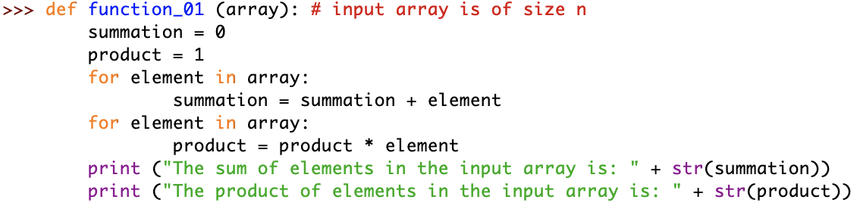

a) O(log n) //logarithmic runtime complexity

b) O(n) //linear runtime complexity

c) O(n^2) //quadratic runtime complexity

d) O(2^n) //exponential runtime complexity

The correct answer is [b]

12) What is the running time complexity of the following function (function_02), assuming the size of input array is “n”?

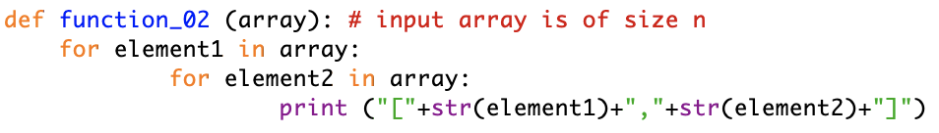

a) O(1) //constant runtime complexity

b) O(n) //linear runtime complexity

c) O(n^2) //quadratic runtime complexity

d) O(2^n) //exponential runtime complexity

The correct answer is [c]

13) What is the running time complexity of the following function (function_03), assuming the size of input array is “n”?

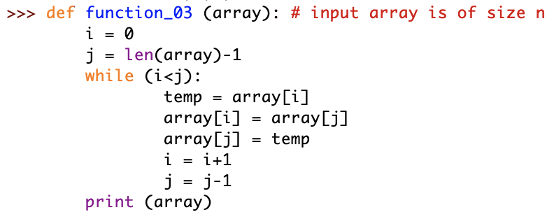

a) O(1) //constant runtime complexity

b) O(n) //linear runtime complexity

c) O(n^2) //quadratic runtime complexity

d) O(2^n) //exponential runtime complexity

The correct answer is [b]

14) What is the running time complexity of the following function (function_04), assuming the size of input array is “n”?

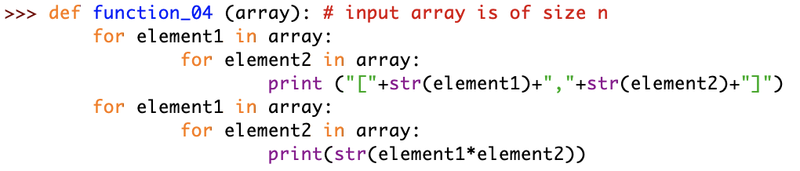

a) O(1) //constant runtime complexity

b) O(n) //linear runtime complexity

c) O(n^2) //quadratic runtime complexity

d) O(2^n) //exponential runtime complexity

The correct answer is [c]

15) What is the running time complexity of the following function (function_05), assuming the size of input array is “n”?

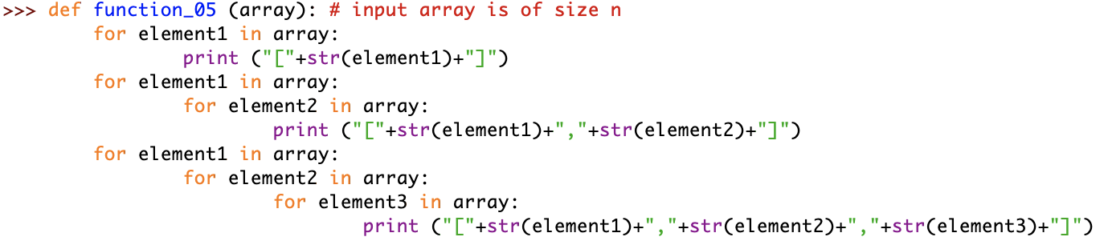

a) O(n) //linear runtime complexity

b) O(n^2) //quadratic runtime complexity

c) O(n^3) //cubic runtime complexity

d) O(2^n) //exponential runtime complexity

The correct answer is [c]

-------------------------------------------

Part 2: True or False (40 Marks)

-------------------------------------------

1. In Python, a function must have at least one parameter.

The above sentence is True or False? [False]

2. In Python, you can define a variable without defining its data type.

The above sentence is True or False? [True]

3. In Python, a function must return a value at the end of the function.

The above sentence is True or False? [False]

4. In Python, a random sequence is reproducible by default.

The above sentence is True or False? [False]

5. In Python, a parameter of a function can be a reference to another function.

The above sentence is True or False? [True]

6. Push and Pop operations pertain to stacks, and Enqueue and Dequeue operations pertain to hash tables.

The above sentence is True or False? [False]

7. Hash tables must store values in either ascending or descending order.

The above sentence is True or False? [False]

8. In a binary tree, a leaf node is a node that has exactly two children nodes.

The above sentence is True or False? [False]

9. Finding the factorial of a given number, n, can be computed using either an iterative function or a recursive function.

The above sentence is True or False? [True]

10. Finding the maximum number in an unsorted array of size “n” can be solved in linear time (i.e., O(n)).

The above sentence is True or False? [True]

11. Finding the minimum number and the maximum number in an unsorted array of size “n” can be solved in linear time (i.e., O(n)).

The above sentence is True or False? [True]

12. Finding the minimum number, the maximum number and the average value in an unsorted array of size “n” can be solved in linear time (i.e., O(n)).

The above sentence is True or False? [True]

13. Using binary search to search for an element in a sorted array has linear time complexity (i.e., O(n)).

The above sentence is True or False? [False]

14. Searching for an element in a binary search tree has linear time complexity (i.e., O(n)).

The above sentence is True or False? [False] (Assuming the tree has n elements. If n is the height of the tree, this statement is true).

15. Using recursion to solve fibonacci series problem has exponential time complexity (i.e., O(2^n)).

The above sentence is True or False? [True]

16. When analyzing the running time complexity of an algorithm, it is correct to drop the constant factors from the analysis.

The above sentence is True or False? [True] (Unless the algorithm already runs in constant time O(1) then you can’t drop the constant terms and say the algorithm runs in O(0) time).

17. When analyzing the running time complexity of an algorithm, it is correct to drop the non-dominant terms from the analysis.

The above sentence is True or False? [True]

18. If an algorithm has running time complexity of O(2n), this means the algorithm running time complexity is actually O(n).

The above sentence is True or False? [True]

19. If an algorithm has running time complexity of O(n+m) and m < n/2, this means the algorithm running time complexity is actually O(n).

The above sentence is True or False? [True]

20. If an algorithm has running time complexity of O(n+m) and m > n, this means the algorithm running time complexity is actually O(n).

The above sentence is True or False? [False]